Think Packet

Name_____________________________________

Period_________

Teacher__________________

[](https://www.google.com/url?sa=i&rct=j&q=&esrc=s&source=images&cd=&cad=rja&uact=8&ved=2ahUKEwie6IvozcHaAhVJmK0KHbJDATEQjRx6BAgAEAU&url=https://vimeo.com/thinkabout&psig=AOvVaw3KxzJ5tRQy-q2EH7A6Vfd_&ust=1524064734525954)

Assessment Tracker

|  |  |  |  |  |  |
| --- | --- | --- | --- | --- | --- |
| 100% |  |  |  |  |  |
| 95% |  |  |  |  |  |
| 90% |  |  |  |  |  |
| 85% |  |  |  |  | **Masters** |
| 80% |  |  |  |  |  |
| 75% |  |  |  |  |  |
| 70% |  |  |  |  | **Meets** |
| 65% |  |  |  |  |  |
| 60% |  |  |  |  |  |
| 55% |  |  |  |  | **Approaches** |
| 50% |  |  |  |  |  |
| 45% |  |  |  |  |  |
| 40% |  |  |  |  |  |
| 35% |  |  |  |  |  |
| 30% |  |  |  |  | **Did Not Meet** |
| 25% |  |  |  |  | **STAAR** |
| 20% |  |  |  |  | **Standard** |
| 15% |  |  |  |  |  |
| 10% |  |  |  |  |  |
| 5% |  |  |  |  |  |
|  | **Pre**  **STAAR** | **Ecology** | **Chemistry** | **Physics** |  |

1. A student is using colored beads to make a model of ammonium sulfate, **(NH4)2SO4.** Nitrogen atoms are represented by blue beads, hydrogen atoms by red beads, sulfur atoms by yellow beads, and oxygen atoms by green beads.

What combination of beads should the student use for the model?

A. 1 blue, 4 red, 1 yellow, and 4 green

B. 2 blue, 8 red, 1 yellow, and 4 green

C. 2 blue, 4 red, 4 yellow, and 4 green

D.1 blue, 8 red, 4yellow, and 4 green

1. An ecosystem that is not sustainable can break down when a natural disaster occurs. This can lead to organisms in the ecosystem either leaving the area or dying off.

Increased biodiversity results in a more sustainable ecosystem because —

1. A. a greater number of plant species means that there is less barren land
2. B. a greater variety of species present allows more organisms to adapt after changes occur
3. C. the transition area between two ecosystems is narrower
4. D. there are fewer species to be affected by environmental stresses
5. Which statement accurately describes the atoms of a specific element?
6. A. A cadmium‚ Cd‚ atom contains 112 protons inside the nucleus and 48 neutrons outside the nucleus.
7. B. A gallium‚ Ga‚ atom contains 31 protons inside the nucleus and 31 electrons outside the nucleus.
8. C. A potassium‚ K‚ atom contains 19 electrons outside the nucleus and 39 neutrons inside the nucleus.
9. D. An aluminum‚ Al‚ atom contains 13 electrons and 13 protons inside the nucleus.
10. Which of the following is most likely to cause a change in the genetic traits in an isolated population of a ground-dwelling lizard species?

A. The exposure of an individual lizard in the population to radiation that causes a mutation that is not passed on to its offspring

B. An unusually dry summer in the lizard population’s ecosystem

C. The introduction of an invasive predator that preys on the brightest-colored individuals in the lizard population

D. A fast-moving wildfire that burns the canopy of the trees in the lizard population’s ecosystem

1. Two forces are applied to a 10 kg box, as shown. The box is on a smooth surface. Which statement best describes the acceleration of the box?



**10Kg**g

A. The box accelerates at 1.7 m/s2 to the right because the net force is 17 N to the right.

B. The box accelerates at 17 m/s2 to the right because the greater force is to the right.

C. The box accelerates at 3.0 m/s2 because the combined forces cause the box to accelerate.

D. The box does not accelerate, because neither force is large enough to move the box.

1. To fight a bacterial infection, a patient was given an antibiotic to take for 10 days. After the patient finished taking the antibiotics as directed, almost all the bacteria were killed. After another 10 days, the patient was sick again with the same type of infection. What most likely happened?
2. A few bacteria survived the antibiotics and stopped reproducing.
3. The patient’s high fever inactivated the antibiotic, allowing the surviving bacteria to grow

rapidly.

1. The antibiotic slowed the life cycle of the bacteria.
2. Some of the bacteria were resistant to the antibiotic, and they reproduced.
3. A comet moving 600 km per minute traveling in a east-to-west direction passed near Earth in 2013. Because the meteor was only 60 m wide and was 30,700 km above Earth’s surface, it was not visible without the aid of a telescope. Which statement describes the comet’s motion?

A. Its velocity was 10 km/s eastward.

B. Its acceleration was 600 km/s2.

C. Its speed was 600 km/s eastward.

D. Its acceleration was 10 km/s2.

1. Some areas of an ocean are known as dead zones. These zones form when excess organic material decomposes. This increased decomposition uses up the oxygen from the water. Which human activity is most affected by the increasing number of dead zones in the ocean?
2. Offshore oil drilling, because water in dead zones is toxic
3. Commercial fishing, because fish cannot survive without oxygen
4. Commercial shipping, because dead zones change the course of ocean currents
5. Sand mining, because oxygen is not available to form the sands on ocean beaches
6. Which of these does NOT describe the cart’s motion on this graph?

[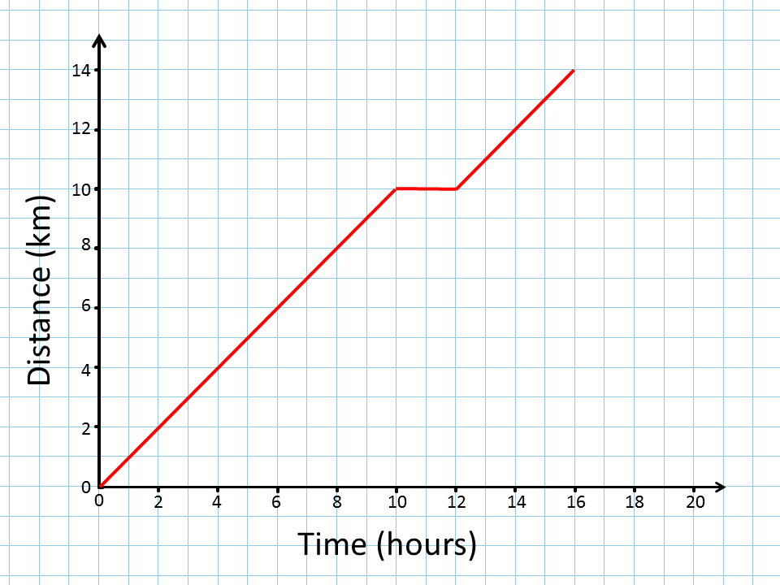](http://www.google.com/url?sa=i&rct=j&q=&esrc=s&source=images&cd=&cad=rja&uact=8&ved=2ahUKEwjh88Cah7_aAhUNS60KHYYRAyUQjRx6BAgAEAU&url=http://www.transum.org/Software/SW/Distance-Time/Graphs.asp&psig=AOvVaw2V68yrOKEF8Cqp6bplVKWU&ust=1523977088132554)

A. The cart moved 10 km away from the starting point between 0 h and 10 h.

B. The cart moved at a speed of 0.3 km/h between 12 h and 16 h.

C. The cart did not move between 10 h and 12 h.

D.The cart moved away from the starting point at a speed of 1 Km/h for 10 h.

1. A chemist made the table below to record some atomic properties of four elements.

|  |  |  |  |  |
| --- | --- | --- | --- | --- |
| **Elements** | **Number of Protons** | **Number of Neutrons** | **Total number of Electrons** | **Number of Electrons in outer shell** |
| Boron | 5 | 6 | 5 | 3 |
| Silicon | 14 | 14 | 14 | 4 |
| Gallium | 31 | 39 | 31 | 3 |
| Lithium | 3 | 4 | 3 | 1 |

Based on the information in the table, which conclusion about the chemical reactivity of these elements is valid?

A. Boron is the most reactive because it has the most protons.

B. Silicon is the most reactive because it has an equal number of protons and neutrons.

C. Gallium is the most reactive because it has many more neutrons than protons.

D. Lithium is the most reactive because it has 1 electrons in the outer shell.

1.  A few years ago the population of male blue moon butterflies on the island of Samoa declined. One hypothesis for the decline of the male butterflies is that a parasite infected the cells of female butterflies. The parasite was passed to offspring through the females’ eggs and killed the male butterfly embryos. At one point during the decline, nearly all the butterflies in the population were females, but after five years the number of males in the population increased significantly.

Which explanation most likely accounts for the increase in the number of male butterflies in the five years after the initial parasite problem?

A. Male butterflies in the population that survived were able to prey on the parasites living in the females’ egg cells.

B. Female butterflies in the population that survived had a genetic adaptation that allowed them to transform into male butterflies.

C. Male butterflies in the population that survived had a gene that made them resistant to the parasite, and they passed the gene on to their offspring.

D. Female butterflies in the population that survived were able to protect the male eggs from the parasite and provide extra care for the male offspring.

1. 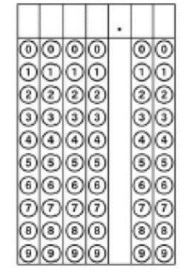A soccer player kicked a 0.45 kg ball at a goal. The ball accelerated at 50.0 m/s2 to reach a speed of 5.0 m/s after it was kicked. During this acceleration, what was the net force on the arrow to the nearest newton?
2. Which statement correctly describes the location and charge of the protons in an atom?

A. The protons are inside the nucleus and have a positive charge.

B. The protons are outside the nucleus and have a positive charge.

C. The protons are inside the nucleus and have a negative charge.

D. The protons are outside the nucleus and have a negative charge.

1. A cannon is shot and motion is shown in the diagram below.

[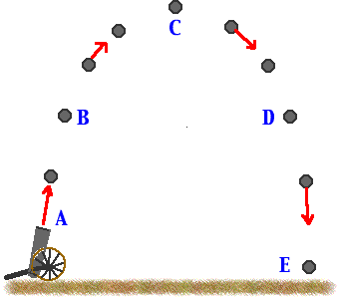](http://www.google.com/url?sa=i&rct=j&q=&esrc=s&source=images&cd=&cad=rja&uact=8&ved=2ahUKEwiAxPeGlb_aAhUMVa0KHQv9AdYQjRx6BAgAEAU&url=http://science.halleyhosting.com/sci/soph/CIM/peke/a8.htm&psig=AOvVaw0f3JM9XP7ONPmVySPiSD0i&ust=1523980777257832)

Which of these correctly describes the potential energy and the kinetic energy of the cannon?

A. When the cannon is at position C, the potential energy is the greatest, and her kinetic energy is the least.

B. As the cannon reaches position C, the kinetic energy and potential energy are equal.

C. When the cannon is at position B, the potential energy decreases, and the kinetic energy increases.

D. As the cannon reaches position D, the kinetic energy and her potential energy decrease.

1. Which statement describes the energy changes that occur when water in a tea kettle is heated on a stove that uses natural gas?
2. A. Some of the chemical energy in the natural gas transforms into thermal energy, which heats the water. Then some of the thermal energy changes into sound energy when the water forms steam and the steam leaves the kettle.
3. B. Some of the thermal energy in the natural gas transforms into sound energy when the water becomes hot. Then some of the sound energy changes into light energy when the kettle becomes warm.
4. C. Some of the electrical energy in the natural gas transforms into thermal energy, which causes the water to form steam. Then some of the thermal energy changes into sound energy and light energy when the steam leaves the kettle.
5. D. Some of the light energy in the natural gas transforms into chemical energy in the water. Then some of the chemical energy changes into kinetic energy when steam leaves the kettle and into sound energy when the water boils.
6. DDT is a pesticide that was once widely used to control agricultural pests and mosquitoes. However, this pesticide caused the eggshells of certain birds, including the brown pelican, to become fragile and thin. The adults would then accidentally crush the eggs while trying to incubate them. What happened to brown pelican populations as a result of DDT use by humans?

A. The populations increased much more slowly.

B. The populations decreased as fewer eggs survived long enough to hatch.

C. The populations remained stable over time.

D. The populations increased as pelicans laid more eggs so that more offspring would survive.

1. An element that is a gas at room temperature and is inert. In which part of the periodic table would this element be located?



1. 1
2. 2
3. 3
4. 4

18. A silver ring reacts with compounds containing sulfur in the air to form silver sulfide, a black substance that makes up the tarnish on the surface of silver objects. To remove the tarnish from the ring, students placed it in a pan lined with aluminum foil and added hot water. Baking soda was added to the hot water and stirred. Students made observations about the process.

Which observation of this process provides evidence of a chemical reaction?

A. Hot water heated the aluminum foil.

B. The liquid solution changed color.

C. The pan was lined with aluminum foil.

D. The hot water cooled.



19. How many valence electrons are in an atom of each element in Group 17 in the periodic table?

1. A student hits a baseball three times. Another student records the distance, the amount of time the ball travels, and the average speed in the table shown below.

|  |  |  |  |
| --- | --- | --- | --- |
| **Hits** | **Distance m** | **Time s** | **Speed m/s** |
| 1 | 25 | 5 | 5 |
| 2 | ? | 5 | 6 |
| 3 | 35 | 17.5 | 2 |

How far did the ball to travel in 5s during hit 2?

A. 5 m

B. 30 m

C. 7 m

D. 10 m

1. The picture shows a student rowing a canoe with a paddle. Which is not an action-reaction pair of forces exists between?

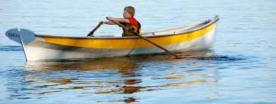

1. the student’s legs and arms
2. the paddle and the student’s hand
3. the paddle and the water
4. the bow of the boat and the water
5. A student drew atomic models of four elements. Based on these drawings, which element is the most reactive?
6. Neon, because it has two energy levels with eight electrons in the second level
7. Chlorine, because it has three energy levels with seven electrons in the third level
8. Gallium, because it has four energy levels with three electrons in the fourth level
9. Tin, because it has five energy levels with four electrons in the fifth level
10. A partial grassland food web is shown.



Which of the following best describes a relationship in this grassland?

1. A. Badgers are top predators because they eat upland sandpipers and beetles.
2. B. A producer–consumer relationship exists between lupines and ants.
3. C. A predator–prey relationship exists between beetles and ground squirrels.
4. D. Upland sandpipers are primary and secondary consumers because they eat grasses and grasshoppers.
5. An energy pyramid is shown.



Which sentence best describes how energy flows through this pyramid?

1. A. Energy is transferred down each level of the energy pyramid.
2. B. The energy lost at each level is consumed by organisms in the top level.
3. C. Energy is transferred from organisms in one level to those in the level above.
4. D. The organisms at the bottom level provide energy directly to organisms in all the other levels.